REL128: The Secrets of Angels and Israel

MTuW 1:00-3:00 PM Th 9:00-11:00 AM Classroom: Norton 308

Professor Steven Daniel Sacks    Office: Prall 108

This course will provide both an introduction to the place of angels and similar divine entities in Biblical, Post-Biblical and Esoteric literatures, with attention to the historical development of Western Monotheisms.

The content and methods in this course correspond to Cornell’s educational priorities:

1. **Knowledge**: Students will integrate and apply knowledge from an interdisciplinary perspective in order to understand the topics of Religion; since no methodology of the academy is “native” to the study of religion, a variety of methodological perspectives are employed in this course.
2. **Inquiry**: Students will encounter a variety of interpretive schema, and will be asked to produce critical analysis to discern the benefits and detriments of differing interpretations and positions.
3. **Communication**:Students will be asked to develop skills in oral presentation and argumentation in every class session and in formal written assignments, and to provide clear structured arguments, with ample use of source materials, on written assignments.
4. **Intercultural Literacy:** Students will be asked to identify with, argue on behalf of, and critique a wide variety of perspectives and positions with which they do not personally identify.
5. **Ethical Behavior:** The study of the history and interpretation of religion is an ethical endeavor.

Class attendance and participation are compulsory for this course, as is the originality of your work; absences without verifiable cause or plagiarism will be cause for failing grades. Late final papers or missed exams will be subject to a minimum of a half-grade penalty. Failure to submit an assignment will be penalized by failure in the course. Those with disabilities must request accommodation from the instructor within the first three days of the course.

Grading:

Class attendance and participation 20%

Paper (3) 60%

Exam (1) 20%

All readings are listed below, due on the day that they appear, and may be downloaded from our Moodle forum. You are expected to bring your readings to class every day.

I will hold regular office hours before class 10:00-11:00 MTuW, but please feel free to contact me at any time if you have questions or concerns about the course. The present schedule and/or readings are liable to be amended as is necessary. Students are expected to complete a significant amount of work outside of the course which supplements scheduled hours within the classroom, and exceeds the government’s regulations on course credit equivalency.

Cornell College expects all members of the Cornell community to act with academic integrity. An important aspect of academic integrity is respecting the work of others. A student is expected to explicitly acknowledge ideas, claims, observations, or data of others, unless generally known. When a piece of work is submitted for credit, a student is asserting that the submission is her or his work unless there is a citation of a specific source. If there is no appropriate acknowledgement of sources, whether intended or not, this may constitute a violation of the College’s requirement for honesty in academic work and may be treated as a case of academic dishonesty. The procedures regarding how the College deals with cases of academic dishonesty appear in The Catalogue, under the heading “Academic Honesty.”

Students who need accommodations for learning disabilities must provide documentation from a professional qualified to diagnose learning disabilities. For more information see cornellcollege.edu/disabilities/documentation/index.shtml

In order to prepare for each class, you will be required to do the following:

1. Marginalia: Print out every reading, and every time you feel the urge to highlight or underline something, write out in the margins why you wanted to underline it. Why is that passage important? Is it a major new point in the argument? A significant piece of support? A summary of the opposition? A particularly strong or particularly weak point? Use the margins to summarize the text, ask questions, give assent and protest vehemently – do not just color the pages. You will submit your marginalia for review on Mondays.
2. Leadership: Every day two or more people will assume the role of leader, and either complete a task that I assign, or compose and post a thesis seeking question to our moodle forum by 7:00 PM the evening before class; this question will seek to clarify the intent and/or argument of our readings – the question will not address questions of fact or content, but rather arguments presented in our readings.
3. Submitted Response: There will be time at the end of each class for each student to reflect on the day’s discussion in a minimum 150 word written response; you may address any point, question or problem which occurred in class that day posed by a leader, another student, me or of your own making. This is an opportunity to dialogue with the content of the class the way that you have the readings; you should seek to reflect, challenge and push your learning in the right direction – and will be asked to submit these responses with your Marginalia on Mondays.

Rubrics

Class Participation:

The grade for class participation will be categorized as follows: “A” for exceptional contributions to our daily discussions and the Submitted Responses, with no missing or late assignments. “A-“ for exceptional contributions, with one missing or late assignment; “B+” for excellent and consistent contributions to our daily discussions and the Submitted Responses; “B” for solid contributions to our daily discussions or Submitted Responses, with one or two missing or late assignments; “B-” for uneven contributions to our daily discussion or the Submitted Responses; C+ for uneven contributions to our daily discussion and the Submitted Responses, with two or three missing or late assignments; “C” and below for poor effort to participate in our daily discussions and the Submitted Responses, with three or more missing or late assignments.

Papers:

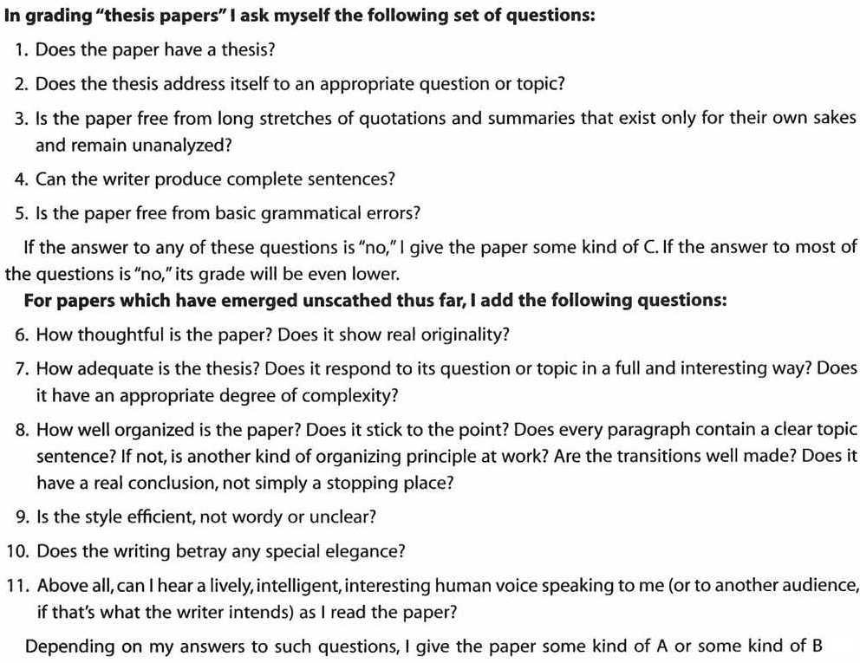

Schedule

Monday, March 18:

Alber, “What is an Angel?” 37-53.

Tuesday, March 19: Angels and Biblical Theology

Bible: https://www.mechon-mamre.org/e/et/et0.htm

* Exodus 32-34; Deuteronomy 12; Isaiah 6; Ezekiel 1; Daniel 10; Proverbs 8
* Find Scholarly Commentaries to Your Assigned Section (Cole Library 222)
* Documentary Hypothesis Handout (1-7)

Wednesday, March 20: Monotheism

Skarsaune, *Is Christianity Monotheistic?* 3409-363.

Kaufmann, “The Bible and Mythological Polytheism” 179-197.

Thursday, March 21: Angels and Human Beings

Genesis 1-2; 6:1-7 and 32:23-33

Kugel, *Traditions of the Bible* 44-84

Schafer *The Jewish Jesus* 197-213

Friday, March 22: **WRITING DAY**

FIRST PAPER DUE SUNDAY, MARCH 24TH AT NOON

Monday, March 25: Secondary Powers

Collins, “Powers in Heaven” 9-28

Hurtado *One God, One Lord* 1-22.

Tuesday, March 26: Enoch and Metatron

Segal, *Two Powers in Heaven* 60-73.

Schafer, *The Origins of Jewish Mysticism* 53-85

Wednesday, March 27: Angelification in the Dead Sea Scrolls

Schafer, *The Origins of Jewish Mysticism* 112-153.

Thursday, March 28: Storming the Palace: *Merkavah* Literature

Schafer, *The Origins of Jewish Mysticism* 243-282, 298-306, 318-327.

Friday, March 29: **WRITING DAY**

SECOND PAPER DUE SUNDAY, MARCH 30TH AT NOON

Monday, April 1: The Foundations of Kabbalah

Scholem, *The Meaning of Torah in Jewish Mysticism* 32-86

Tuesday, April 2: Divine Personae: The *Sefirot*

Scholem, *Major Trends: The Zohar II Theosophical Doctrine of the Zohar* (175-203)

The Zohar *Be-Reshit*

Wednesday, April 3: Renaissance Magic

Walker *Spiritual and Demonic Magic* 75-84

Lehrich *The Language of Demons and Angels* (Selections)

Thursday, April 4: John Dee and Enochian Angelology

Asprem, *Arguing with Angels* 11-28

Szonyi, *John Dee’s Occultism* 181-240

Friday, April 5: Friday, March 29: **WRITING DAY**

THIRD PAPER DUE SUNDAY, APRIL 7TH AT NOON

Monday, April 8: An Angel for Every Need

# Virtue, *Angels 101* (Selections)

Tuesday, April 9:

Review Session

Wednesday, April 10:

FINAL EXAM at 9:00 AM